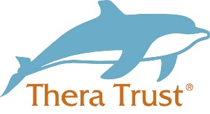
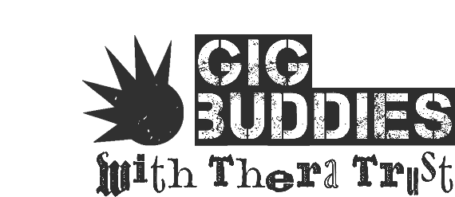

VOLUNTEERING APPLICATION FORM
ABOUT YOU
Name
Address
Telephone number
Email address
REFERENCE DETAILS
Referee guidelines
Please provide details of 1 person who we can contact as referee; to comment on your suitability to volunteer for Gig Buddies. The referee must have known you for over 1 year ideally in a professional capacity although this is not a necessity.
Referee
Name
Address
Telephone number
Email address
ADDITIONAL INFORMATION
Health
We ask this so that appropriate adjustments can be made to better support you in your role
Do you have any disabilities or health needs that we should be made aware of? |  | Yes |  | No
 |  | If yes; please provide details:
Volunteering
If you are from the UK you are free to volunteer. The majority of European Union (EU) citizens are also free to volunteer within the UK. For those outside the EU you need to check that your visa allows you to volunteer. We may ask to see documentation providing eligibility to volunteer in the UK.
Are you entitled to volunteer in the UK? |  | Yes |  | No
CRIMINAL CONVICTIONS
Criminal Conviction Guidelines
Gig Buddies volunteers are in direct contact with vulnerable adults. All volunteers will need to have a police check through Protecting Vulnerable Groups before they can start. All convictions current or “spent” (including fines and driving convictions but not parking fines) must be declared. Please note that this does not mean that all convictions will exclude you from volunteering with us. We will assess any convictions on an individual basis and the PVG will be paid for by Gig Buddies.

Do you have/or have you ever had any criminal convictions(s), caution(s), warning(s) and/or reprimand(s)? |  | Yes | No
 |  | If yes, please provide details:
APPLICATION
Covering Letter
In the space below please include a summary of the following;
- Why you want to be a Gig Buddy
- What would make you a good Gig Buddy
- What type of gigs you are interested in taking your Gig Buddy to
- Tell us anything else you think would be useful for us to know

WHAT ARE YOU INTERESTED IN GOING TO? (Please tick all items you are interested in)
- Music
- Classic Rock ☐
- Metal and Heavy Rock ☐
- Indie/Alternative Rock ☐
- Hip-Hop ☐
- Pop Music ☐
- Rock and Roll ☐
- Swing ☐
- Jazz ☐
- Classical/Orchestral ☐
- Folk ☐
- Blues ☐
- Country ☐
- Reggae/Ska ☐
- Electronic Dance Music ☐
- Festivals ☐
- Other:

- Comedy ☐

- Films
- Comedy ☐
- Drama ☐
- Family Films ☐
- Horror ☐
- Thriller ☐
- Other:

- Sports
- Football ☐
- Rugby ☐
- Golf ☐
- Other:

- Theatre
- Musicals ☐
- Plays ☐
- Dance ☐
- Opera ☐

- Museums ☐

- Art Galleries ☐

- Any other interests:

Consent Forms
Form 1 – Personal consent
I would like to give my consent to the following
□ I have read and understood the consent process. (Below)

□ I give my consent for Thera Group to use my images / video for promotional use (items listed below)
□ I give my consent for Thera Group to use my stories for promotional use such as (items listed below)

□ I consent for Thera Group to share my story with social care professionals, such as social workers
□ I DO want my real name to be used.

I give consent for Thera Group to use
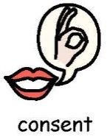
□ my story □ my photos / videos for the following:
□ Thera’s/Gig Buddies Facebook and Twitter page
□ Thera’s website
□ Gig Buddies Newsletters and Materials
□ Fundraising leaflets
□ Presentations to social care professionals
□ Recruitment materials

Description of photo/story: - For everything please write ‘Any and all’
Print name:
…………………………………………………………………………………………………………..
Signed:
…………………………………………………………………………………………………………..
Date:
………………………………………..………………
Thera Company:
Gig Buddies with Thera Trust


We will retain and use your information for the purposes indicated on this form, but if you would like to withdraw your consent at any time please contact Gig Buddies at:
- Gigbuddies@thera.co.uk

Keep in touch with us.
Gig Buddies with Thera Trust would like to keep you informed about what is happening in the organisation. Please indicate on this form if you consent to be contacted by Gig Buddies and how.
If we do not receive any communication from you in one month we will remove your details from our contact list. You can contact us at any time to start receiving information again.
I give my consent to Thera Trust sending me communications and information about the Gig Buddies with Thera Trust Project.

Please indicate in the boxes below how you would like to be contacted by Thera:
Email – Please write the address you with for us to use

____________________________________________________
Post – Please write the address you wish for us to use.
_____________________________________________________
Phone (text message or phone call)________________________

We will retain and use your contact details for the purposes indicated on this form, but if you would like to withdraw your consent at any time please contact Thera in one of the following ways:
- dataprotection@thera.co.uk
- Gigbuddies@thera.co.uk
- By post to: FAO Data Protection, Thera Trust, The West House, Alpha Court, Swingbridge Road, Grantham, Lincolnshire, NG31 7XT
You can view our privacy notice by visiting our website www.Thera.co.uk
RELATIONSHIP TO THERA (eg. Family member / friend / care manager etc.) Gig Buddies Volunteer
PRINT NAME……………………………………………………………………
SIGNATURE…………………………………………………………………….
DATE.……………………………………………………………………………
When you have completed this form please return to your local area coordinator:

Gig Buddies Edinburgh: Sam Maggs email: samuel.maggs@thera.co.uk
Gig Buddies Glasgow Molly Tavella email: Molly.tavella@thera.co.uk
Gig Buddies West Lothian Debbie Forsyth email: Debbie.forsyth@thera.co.uk

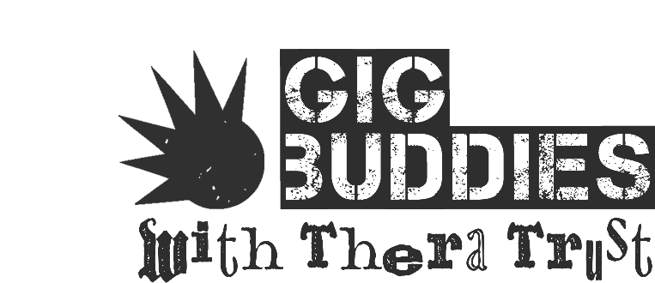

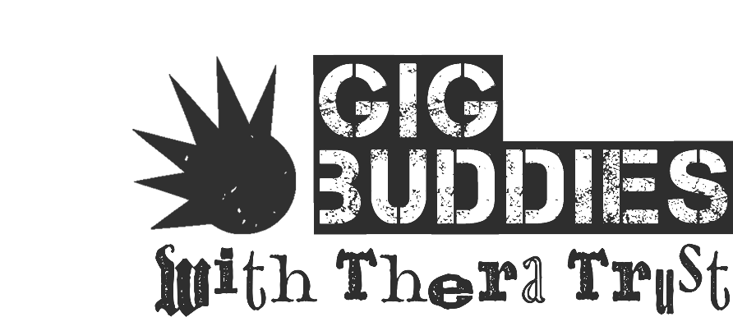
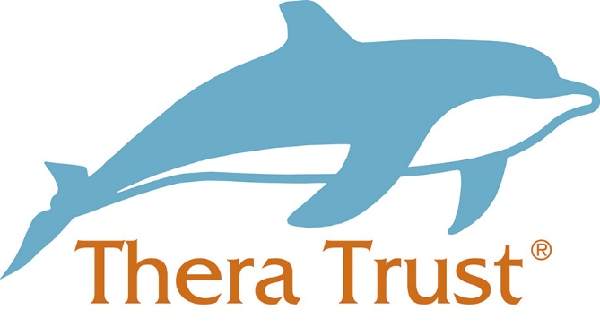

Thera Group Consent Process
Your Stories – Words and Pictures
Introduction

1. We would like to share people’s stories in words and pictures as part of telling people about the work that Thera does. This will help Thera to be known by people with a learning disability, their circles of support, professionals and funders.

What is consent?
2. Consent is defined as ‘acceptance or approval of what is planned or done by another’ (thefreedictionary.com).
3. This means that we will only use your written or spoken story and photographs or film of you to tell people about Thera, if you say YES we can.

4. You can agree to give consent for your image to be used by Thera by filling in the form at the end of this document. We cannot accept consent by email.

What the law says about consent
5. It is not currently against the law to take somebody’s photo or record their image without their consent, it may be invading a person’s privacy if their photo is used for commercial purposes without telling them first.
6. It is not against the law to tell someone else’s story without consent, but it would be against the law (Data Protection Act 1998) to include any personal details such as a full name, date of birth or address
7. Therefore it is important that you fill in a consent form that says YES it is OK for Thera to use your image for promotional purposes – telling people about what Thera does.


How Thera will use my image
8. When you send us a story and give consent for us to share it, this could be used on a range of materials that promote Thera. This includes newsletters, leaflets and Thera’s website.
9. When your image has appeared on a publication, it is available to the public forever. For example, if your image is used on a leaflet and given out to the public, we cannot control who then sees your picture. Similarly on our website, we cannot stop people from saving an image to their computer if they wished to.

10. Once you have told us we can use your story and image to tell people about Thera, you will not be informed every time your image is being used to promote Thera unless it is being used for a purpose you have not consented to or an exceptional circumstance. These circumstances include but are not limited to press releases, social media and printed banners or exhibition stands.

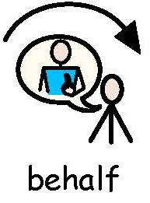
Communicating consent on somebody’s behalf
11. Thera support people with lots of different needs. It is important that we can share their stories and achievements.

12. If a person is unable to give consent for themselves, then consent can be given by the legal appointee and it must be evidence that the person does not have capacity to consent. For this to happen, a best interests meeting must take place. This document should be taken into consideration in order to make a decision as to why they think the person’s image, and story should be used to promote Thera. This must be written in detail on the form at Appendix 2. This meeting could be an email communication, phone call or face-to-face meeting but it must be documented.
13. The person signing on behalf of the individual must provide evidence that the person supported does not have capacity to sign the form themselves. They will also need to provide evidence that they can consent legally on the individual’s behalf.
14. Please make reference to the policies detailed at the end of this document in order to make this decision.
15. If consent cannot be gained, it may be appropriate to make the story anonymous by changing the names used. In this case, an image could not be used alongside the story.

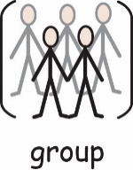
Consent for large groups
16. At an event or meeting, you need to make people in attendance aware if videos are being recorded or photographs taken. Allow people to opt out of having their image captured.

How we record your consent

17. If you are giving consent for yourself, please fill in Appendix 1. If you are giving consent on behalf of somebody else, please fill in Appendix 2.
18. Return a copy of this form to the Grantham office where it will be stored along with the original image(s) submitted for use.
19. Multiple forms do not have to be filled in every time a person submits an image. A copy of the original consent form will be stored with the new photograph. The person can still opt out at any time. Thera will contact you for consent to use each new photo if you have indicated on the form that you want them to.
Reviewing consent
20. Consent will last for 1 year from the date you write on the form. After 2 year, you will be asked if you still consent to your image being used.

21. You can remove your consent at any time. However, please consider the words in the ‘how Thera will use my image’ section.
22. If your image has been used on a printed publication and you choose to remove your consent, we can only destroy copies of publications that have not been distributed. Images used on the website can be removed at any time on request.

