
Quality Connect
Welcome to Quality Connect
Quality Connect is a leaflet designed to help your wellbeing and feel connected with each other. We welcome new ideas from everyone.

What is in this leaflet
- Why Poetry is Important
- Introducing Elizabeth and the new Toolkit
- Behind my Smile by Elizabeth Felton
- Emotional Wellbeing
- Mindfulness
- Handmade Jewellery
- Chicken and Sausage Bacon Bundles
- Support Contact Details
- Reminders and Information Page
- Meeting Details


Thank you to Elizabeth Felton and Harry Heppell for all your contributions for the Quality Connect.

Why Poetry is Important

Research shows that poetry; reading, writing, or speaking it can help support our mental health, especially in times of great need. Poetry can provide comfort and boost your mood during periods of stress, trauma, and grief.

Poems are Important because words have Power. Poems can be like a magic spell and can transform the way we see the world and even heal us. Words have the power to heal and the power to destroy. What we say has a lasting impact on those around us. Poems that use words carefully and with intention are often seen as pieces of art.

Poems are Important for teaching Empathy. Poems help us feel what others are feeling, which helps us connect to them and understand their perspectives. The more understanding we have for others, the more likely we are to put ourselves in their shoes and try to find solutions that work best for everyone involved.

Poems are Important because they offer us a different Perspective. When we read poems, they give us a new perspective on the world. Poems can offer us a fresh, new outlook on life. It is often difficult to understand the world through someone else’s eyes, so poetry gives us the opportunity to learn about another perspective.
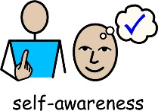
Poems are Important for encouraging Self-Reflection. Poems can give us the chance to explore our emotions and thoughts, which can be helpful if we are looking for a better understanding of ourselves.

Poems are a great way to express Emotions. Poems are a great way to express your emotions when you cannot say what’s on your mind. Sometimes things are too hard to put into words. But poetry is a good place for those difficult emotions to live. Poems are often short, and nothing needs to be explained in detail. Whether you are writing them or reading them, poems are a great way to express yourself.


Elizabeth Felton, Quality Assessor, writes her own poetry. Her poems are about herself, mental health, her struggles, self-acceptance, how she feels inside, how she sees the world and a reflection of her past. Some of Elizabeth’s Poetry are words only, and some have pictures to explain the poetry. Elizabeth has written a very moving poem called Behind my Smile.
Elizabeth Felton is going to be sharing her creative hobbies with us in each issue.


In the next issue of Quality Connect we will be sharing some of Elizabeth Felton’s personalised Journal making.
Self-care starts with you allowing yourself to be vulnerable and honest. Through self-reflection, you can finally let out everything you have been holding back. Your journal is your own personal platform where you can document your worries, stresses, and successes.
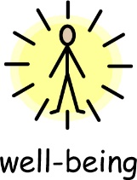

Wellbeing Toolkit

With each Quality Connect, you will receive a Wellbeing exercise that you can complete. If you choose you can share this with others. Each exercise will build into a toolkit. We have sent you the first exercise in a folder to get you started.

Behind my Smile written by Elizabeth Ann Felton

Behind my smile, there is a troubled soul.
I dream one day I will be able to take back my control. Behind my smile, I may walk that extra mile.
I suppose I need to go at my own pace. I have no real reason to be in a race.
Oh well I will just have to sit on the shelf until I start believing in myself.
Behind my smile. Never mind... time will tell.
I got to look forward.
I must never look behind.
Behind my smile.
I have got to try to confront it all.
I can be invincible whenever I put my mind to it because anything is possible. I must trust my family and friends.
They may be wits end with me, but they still stay with me to help me clear up my loose ends. Take their hand.
They are taking me to a safe place to land.
Behind my smile.
They are always showing me the way.
They are telling me that I will be okay.
I must learn to take more risks, go for it, learn from it.
Embrace it and enjoy it.
Behind my smile.

Emotional wellbeing is how well people are able to process their emotions and cope with life challenges. Below are some tips for improving and taking care of your emotional health and wellbeing.

Stay in touch. Do not withdraw from life. Socialising can improve your mood. Staying connected with friends and family or colleagues means you have someone to talk to when you feel low.

Face your fears. Do not avoid the things you find difficult. When people feel low or anxious, they sometimes avoid talking to other people. Facing up to these situations will help them become easier.


Keeping a journal about your feelings has many health benefits and according to research it is a highly effective technique for managing stress and anxiety. It can also help boost self-confidence, improve mood, relieve depression, and improve focus, further reducing your anxiety.

Listen to your favourite music or podcast. Music can be powerful. It can change our mood and, research shows, even change our behaviour.
Podcasts are a terrific way to take a break and focus on you. They offer you a chance to learn, reflect, grow, or immerse yourself in a story on the go, and can even boost your mood!



Doing something you love is good for your emotional wellbeing. Recognising what you are good at is a good way to enjoy yourself and have a sense of achievement.

Mindfulness involves paying attention to what is going on inside and outside of ourselves, moment by moment. This can help us to enjoy life more and understand ourselves better.

How to be more mindful:

- Take notice. Reminding yourself to take notice of your thoughts, feelings, and the world around you is the first step to mindfulness.
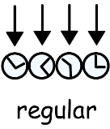
- Keep it regular. It can be helpful to pick a regular time, such as a morning journey to work or a walk at lunchtime, or a certain time of the day you read a book.
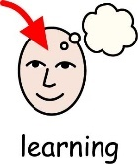
- Try something new. Trying new things, such as sitting in a different seat in meetings or going somewhere new for lunch, can also help you notice the world in a new way.
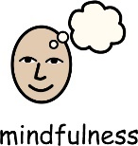
- Free yourself from the past and future. You can practise mindfulness anywhere, but it can be especially helpful to take a mindful approach if you realise that, for several minutes, you have been trapped in reliving past problems or pre-living future worries.

- Be kind to yourself. Remember that mindfulness can be difficult, and our minds will always wander. Try not to be critical of yourself. When you notice your mind wandering, you can just gently bring yourself back to the exercise.


Elizabeth Felton has been making jewellery since 2008. Her friend Terri also does jewellery making and they have a special friendship. Elizabeth has sold some of her jewellery to her friends and family and in the past at a Brownies evening group.
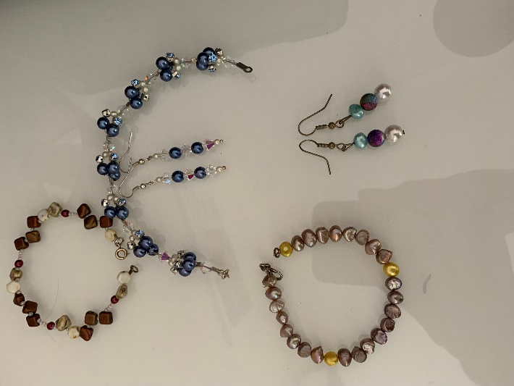

Elizabeth Felton’s Handmade Jewellery


Chicken and Sausage Bacon Bundles
Serves 4
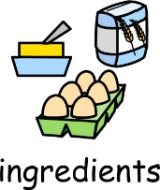
Ingredients:
8 skinless chicken thighs, boned
Salt and freshly ground black pepper
2 teaspoons of finely chopped fresh sage
8 pork chipolata sausages
8 long rashers smoked streaky bacon; rind removed
A little vegetable oil, for brushing
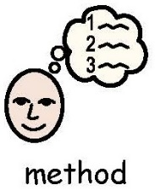

Method
- Preheat the oven to 220°C/200°C fan/gas 7.

- Lie the chicken thighs flat, skinned side down on the work surface. Season with salt and pepper and sprinkle with a little sage. Roll up a sausage in each thigh, then wind a bacon slice around the chicken.

- Brush a roasting tin with oil, sprinkle with a little salt and pepper and put the meat into the tin. Brush each roll with oil, then bake for about 25 minutes or until browned and cooked.

- Cook in the roasting oven on the highest set of runners for about 25 minutes.

Recipe sourced by Harry Heppell from Mary Berry and Lucy Young at Home Cookery Book.
Support Contact Details
There is a helpline that staff can call if they are worried about anything.
The Employee Assistance Programme offers staff confidential advice and support to help you work through worries such as home or work issues, finances, challenging situations, or medical concerns.
It is free and can be accessed 24 hours a day, 7 days a week: 0800 068 6729



There are Mental Health First Aid Champions across Thera Group. They have:
- The knowledge and confidence to provide Mental Health First Aid for the most common mental health issues.
- An understanding of how to help build a mentally healthy workplace, challenge stigma and support positive wellbeing.
For more information, please visit the Thera Trust Website:
www.thera.co.uk/staff/health-and-wellbeing/mental-health-first-aiders/

Reminders and Information Page






Remember you can follow us on Facebook through Thera Trust and on Twitter @qualitychecking
We continue to recruit for Quality Assessors and Quality Supporters across The Quality Company. Remember by referring a friend, you could receive up to £300.
We are asking all staff to let us know if they have any ideas for future issues of the Quality Connect.
Please send your ideas to: ElizabethMiles@thequalitycompany.co.uk
Reminder to send things back promptly to Quality Admin.
If you would like to share stories about Quality Checks or things you get up to outside of work, we have a new email address you can send stories to: stories@thequalitycompany.co.uk

Meeting details



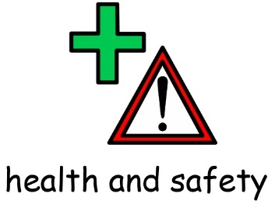


To find out who your local Health and Safety and ECC Representative is, please contact your Line Manager.
If you are interested in becoming a Health and Safety or ECC Representative, please let us know.

